Comparison and Contrast of the Major League Baseball website (mlb.com) and the National Football League website (nfl.com)
Student’s Name
Institutional Affiliations

Comparison and Contrast of the Major League Baseball website (mlb.com) and the National Football League website (nfl.com)
Introduction
A properly designed website has to adequately incorporate the four main principles of proximity, alignment, repetition, and contrast. Proximity in a web design context refers to the physical relationships and spaces between the website components and is important because it determines the quality of flow between different components of the website (Boudreaux, 2012). Alignment refers to how the website components are situated on the web page (Boudreaux, 2012). Repetition, on the other hand, refers to the replication of certain visual elements on the website and is important in enhancing the continuity of a web page (Boudreaux, 2012). Conversely, contrast is applied when two or more components of the website are presented differently using colors and other methods to separate different parts of the web page (Boudreaux, 2012). The Major League Baseball website (mlb.com) and the National Football League website (nfl.com) show several similarities and differences regarding these four principles.
Proximity
Both mlb.com and nfl.com effectively use white space to separate different elements and create margins and gutters between the different elements (Boudreaux, 2012). Additionally, both websites use adequate padding to surround the content in a specific element of the website (Boudreaux, 2012). However, mlb.com has more white padding around the content compared to nfl.com, which creates a generally neater outlook of the former website. For instance, the content titled “Short, yes … but sweet” in mlb.com is surrounded by more spacious padding compared to the content titled “Top Free Agents Still Available” in nfl.com (MLB, 2021; NFL, 2021). Also, the padding around the different elements in nfl.com has margins with sharp perpendicular corners, while the padding in mlb.com has slightly rounded corners. Furthermore, the “Latest News” sidebar in mlb.com has a more ordered list that uses bullet points to separate the sentences while the “News” sidebar in nfl.com has a less ordered list with random sentences (Boudreaux, 2012; MLB, 2021; NFL, 2021).
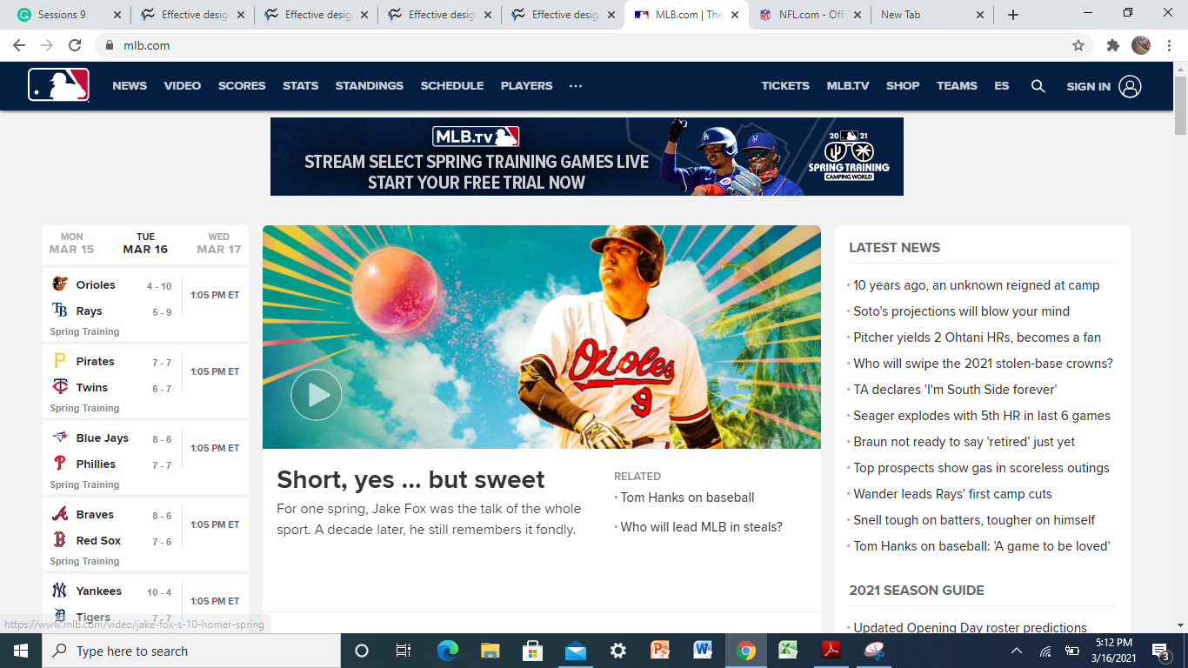
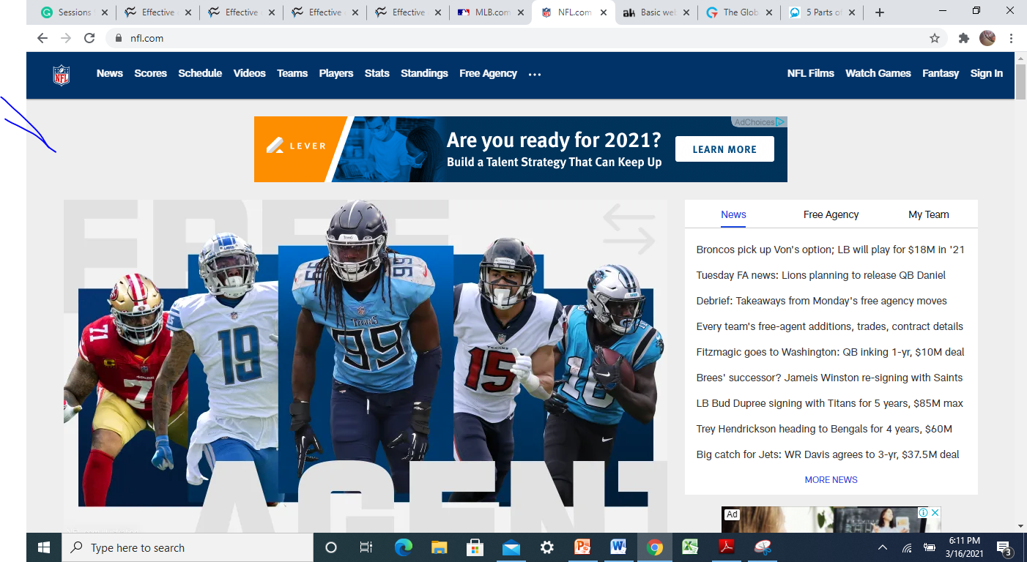
Alignment
Both websites use an alignment strategy that allows them to place the elements with similar content in the same place. For instance, the “Free Agency” segment in nfl.com contains videos related to the current free agency news in the National Football League (NFL, 2021).
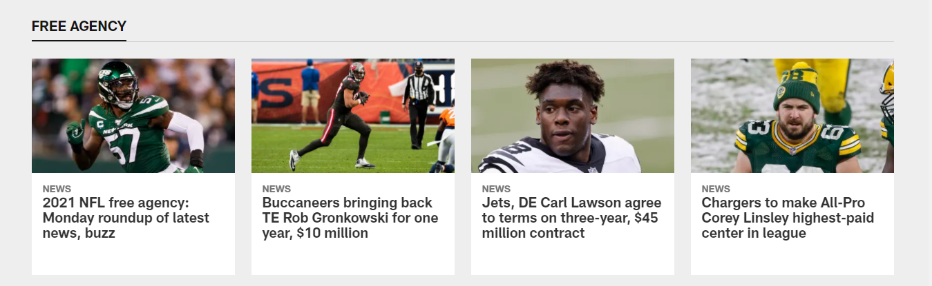
Similarly, mlb.com uses sidebars on the left to place related elements in the same position on the website page. For instance, one sidebar provides content related to Hank Aaron’s baseball career (MLB, 2021).
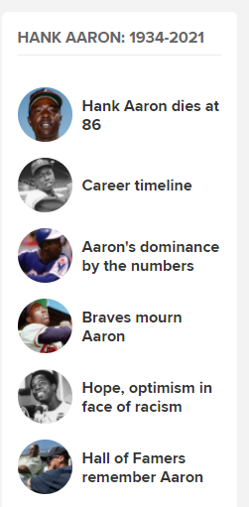
As such, both websites place similar elements together to allow the reader to create a connection between similar elements in the two websites (Boudreaux, 2012). This alignment strategy creates order in the placement of the elements within the website (Boudreaux, 2012). Nonetheless, the videos in mlb.com are arranged vertically while the related videos in nfl.com are arranged horizontally.
Repetition
Repetition can be illustrated in the two websites by analyzing the consistency of the fonts used, spatial relationships, colors, and shapes. For starters, mlb.com has employed the same font type, size, and color in the headings of its sidebars. Additionally, the spaces between the sidebars are similar, thus ensuring a consistent spatial distance between them. Also, these sidebars are of the same shape, and the padding around each of them is consistent as seen in the image below.
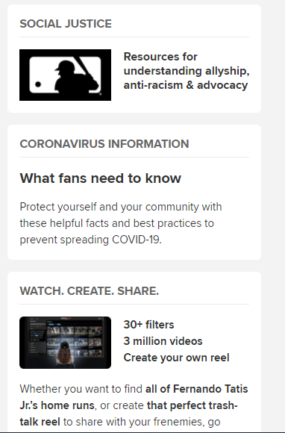
Similarly, nfl.com has employed the same font, shape, and size in the titles of the videos and the headings of the different categories of videos. 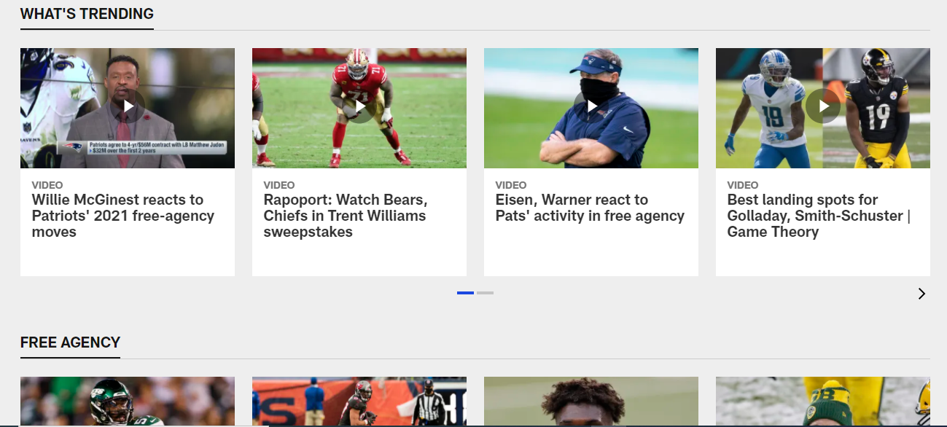
Additionally, the spacing between the videos is consistent, as well as the white space surrounding the video titles. Also, the padding around each video has the same sharp perpendicular corners that are maintained throughout the website. The repetitions in the two websites differ based on what is repeated throughout the websites, such as the different fonts used in mlb.com versus nfl.com.
Contrast
The use of contrast in mlb.com and nfl.com can be most easily identified in the footers of the two websites. Both websites use different colors, fonts, sizes, and positions of elements (Boudreaux, 2012). In mlb.com, the footer has a grey background color which contrasts with the white used in the other parts of the website. As for the contact information, mlb.com has used different colors in the logos that represent Facebook, Twitter, and Instagram. These colors are also different from the grey in the background. Additionally, the words “Cookie Settings” are written in green, and are isolated in a rectangle with green margins (MLB, 2021). Different fonts are also seen in the footer.
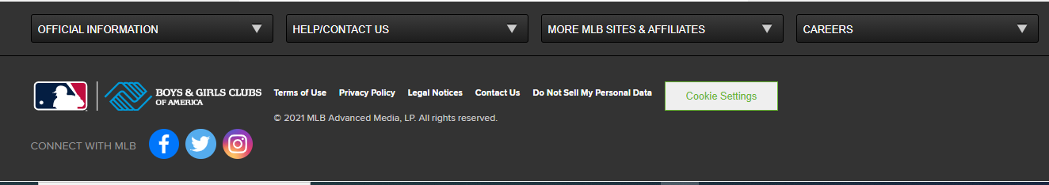
Similarly, the footer in nfl.com has a grey and blue background that is different from the white used in other parts of the website. The NFL team logos are also in different colors and shapes compared to the color of the background of the footer.
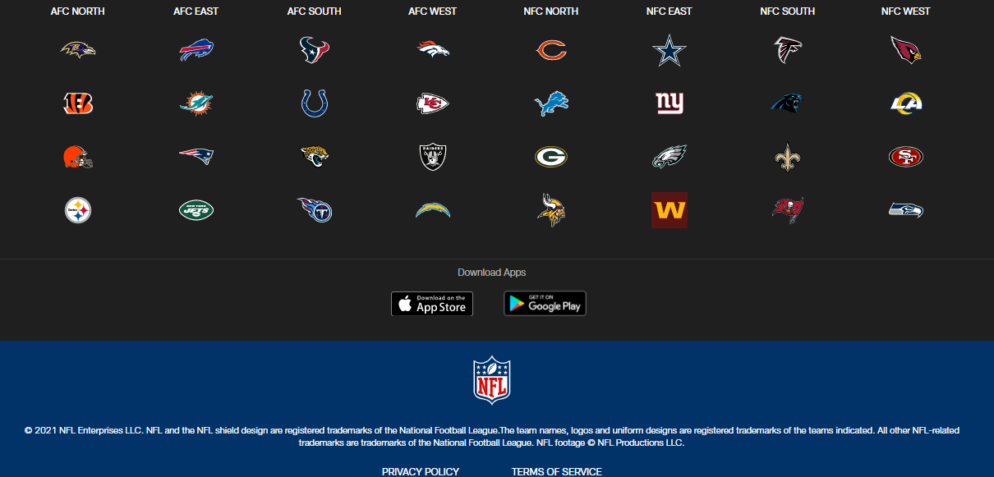
Conclusion
Therefore, both mlb.com and nfl.com exhibit various similarities and differences regarding the various aspects of proximity, alignment, repetition, and contrast in the website design. Although both websites effectively utilize white spaces to separate the different elements, mlb.com uses more spacious white padding around its content and a more orderly arrangement of the content in the sidebars compared to nfl.com. Additionally, the alignment of both websites places related content such as videos in the same segment, although the videos in mlb.com are vertically aligned while the related videos in nfl.com are horizontally aligned. Nonetheless, both websites exhibit repetition in the font type, shapes, and sizes used, as well as the spacing between the different elements of the websites. Similarly, both websites utilize contrast in their footers especially through the use of different colors and fonts to provide related information. However, the footers in the websites use different colors and contain different content. Consequently, a comparison of mlb.com and nfl.com illustrates how proximity, alignment, repetition, and contrast can be used differently in web design.
References
Bordeaux, R. (2012). Effective Design Principles for Web Designers: Alignment. Tech Republic. https://www.techrepublic.com/blog/web-designer/effective-design-principles-for-web-designers-alignment/
Bordeaux, R. (2012). Effective Design Principles for Web Designers: Contrast. Tech Republic. https://www.techrepublic.com/blog/web-designer/effective-design-principles-for-web-designers-contrast/
Bordeaux, R. (2012). Effective Design Principles for Web Designers: Proximity. Tech Republic. https://www.techrepublic.com/blog/web-designer/effective-design-principles-for-web-designers-proximity/#:~:text=Proximity%20for%20web%20design%20purposes,or%20dissimilar%20should%20be%20separated
Bordeaux, R. (2012). Effective Design Principles for Web Designers: Repetition. Tech Republic. https://www.techrepublic.com/blog/web-designer/effective-design-principles-for-web-designers-repetition/
MLB. (2021). https://www.mlb.com/
NFL. (2021.). https://www.nfl.com/
The Writing Center. (2021). Comparing and Contrasting. The University of North Carolina at Chapel Hill. https://writingcenter.unc.edu/tips-and-tools/comparing-and-contrasting/

